300986134 PARTH CHANDGADHIYA

Contents

* ANSWER 01 CODE:- 2
* ANSWER 01 SCREEN SHOTS: 2
* ANSWER 02 Flowchart: 3
* ANSWER 03 CODE: 4
* ANSWER 03 SCREEN SHOTS: 5

1. LOW RATING 6
2. MEDIUM RATING 7
3. HIGH RATING 8

* ANSWER 04 CODE: 8
* ANSWER 04 SCREEN SHOTS: 9

1. LOW RATING 9
2. MEDIUM RATING 10
3. HIGH RATING 11

* ANSWER 05 CODE: 12
* ANSWER 05 SCREEN SHOTS: 12

1. PAID 12
2. NOT PAID 14

* ANSWER 06 CODE: 14
* ANSWER 06 SCREEN SHOTS: 16
* ANSWER 07 Flowchart: 17
* ANSWER 08 CODE: 18
* ANSWER 08 SCREEN SHOTS: 21

1. IS MEMBER AND QUATITY IS LESS THAN OR EQUAL TO 3 22
2. NOT A MEMBER AND QUATITY IS LESS THAN OR EQUAL TO 3 23
3. IS MEMBER AND QUATITY IS LESS THAN OR EQUAL TO 6 BUT GREATER THAN OR EQUAL TO 4 24
4. NOT MEMBER AND QUATITY IS LESS THAN OR EQUAL TO 6 BUT GREATER THAN OR EQUAL TO 4 25
5. IS MEMBER AND QUATITY IS LESS THAN OR EQUAL TO 10 BUT GREATER THAN OR EQUAL TO 7 26
6. NOT MEMBER AND QUATITY IS LESS THAN OR EQUAL TO 10 BUT GREATER THAN OR EQUAL TO 7 27
7. IS MEMBER AND QUATITY GREATER THAN 10 28
8. NOT A MEMBER AND QUATITY GREATER THAN 10 29

**ANSWER 01**

# ANSWER 01 CODE:-

DECLARE

lv_test_date DATE := '2012-DEC-10';

lv_test_num CONSTANT NUMBER(3):= 10;

lv_test_txt VARCHAR2(10);

BEGIN

DBMS_OUTPUT.PUT_LINE(lv_test_date);

DBMS_OUTPUT.PUT_LINE(lv_test_num);

lv_test_txt := 'Parth';

DBMS_OUTPUT.PUT_LINE(lv_test_txt);

END;

# ANSWER 01 SCREEN SHOTS:

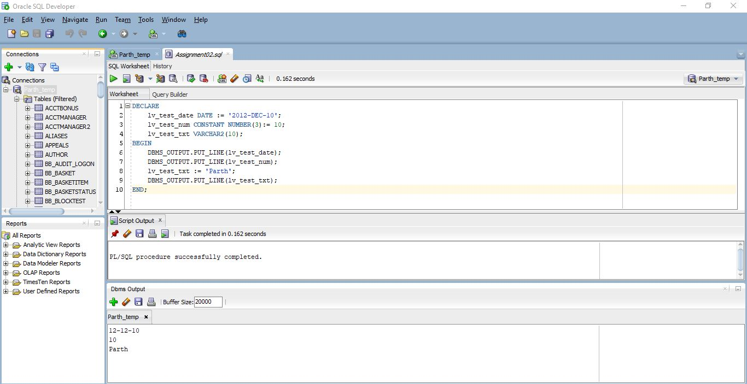

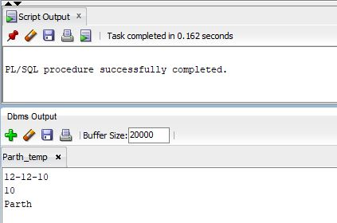

**ANSWER 02**

# ANSWER 02 Flowchart:



**ANSWER 03**

# ANSWER 03 CODE:

DECLARE

lv_test_total_purchase NUMBER(10,2) := 10.02;

lv_test_customer_ranking_high VARCHAR2(10):= 'High';

lv_test_customer_ranking_med VARCHAR2(10):= 'Medium';

lv_test_customer_ranking_low VARCHAR2(10):= 'Low';

BEGIN

IF lv_test_total_purchase > 200 THEN

DBMS_OUTPUT.PUT_LINE('Total Customer Purchase for $'|| lv_test_total_purchase ||' is Ranked: '||lv_test_customer_ranking_high);

ELSIF lv_test_total_purchase <= 200 AND lv_test_total_purchase > 100 THEN

DBMS_OUTPUT.PUT_LINE('Total Customer Purchase for $'|| lv_test_total_purchase ||' is Ranked: '||lv_test_customer_ranking_med);

ELSIF lv_test_total_purchase <= 100 AND lv_test_total_purchase > 0 THEN

DBMS_OUTPUT.PUT_LINE('Total Customer Purchase for $'|| lv_test_total_purchase ||' is Ranked: '||lv_test_customer_ranking_low);

ELSE

DBMS_OUTPUT.PUT_LINE('Please Check Your Entered Value');

END IF;

END;

# ANSWER 03 SCREEN SHOTS:

## LOW RATING

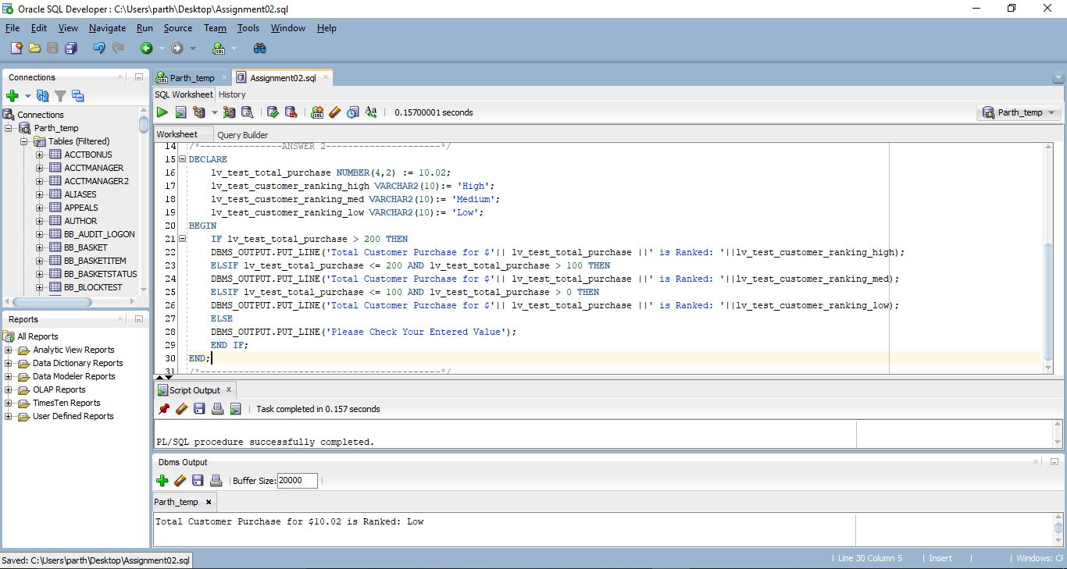

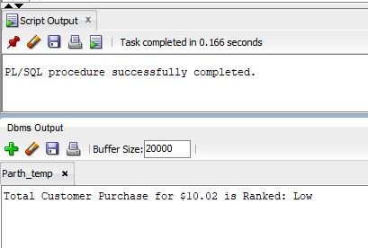

## MEDIUM RATING

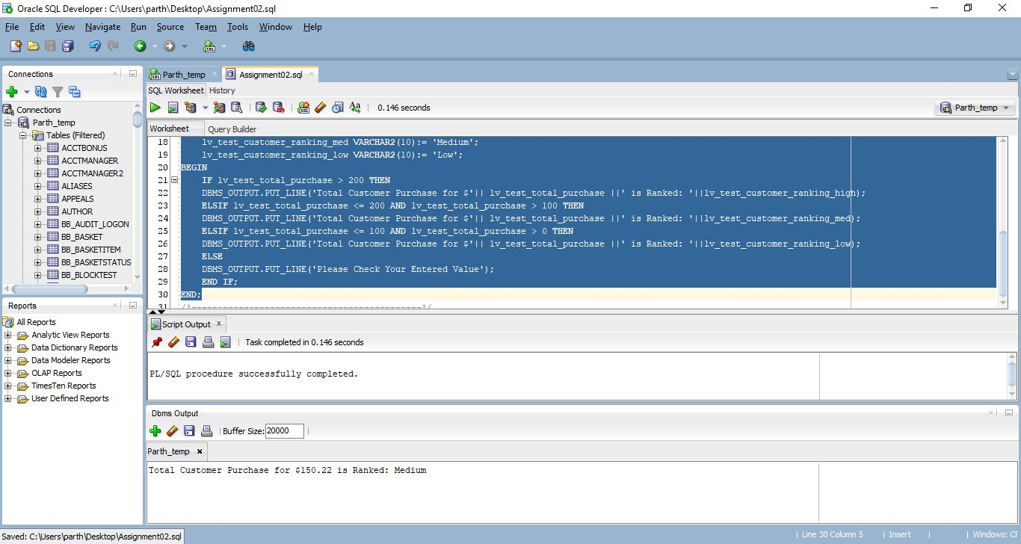

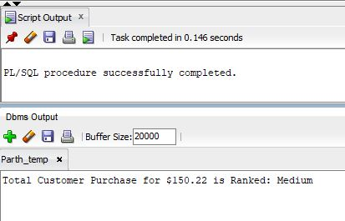

## HIGH RATING

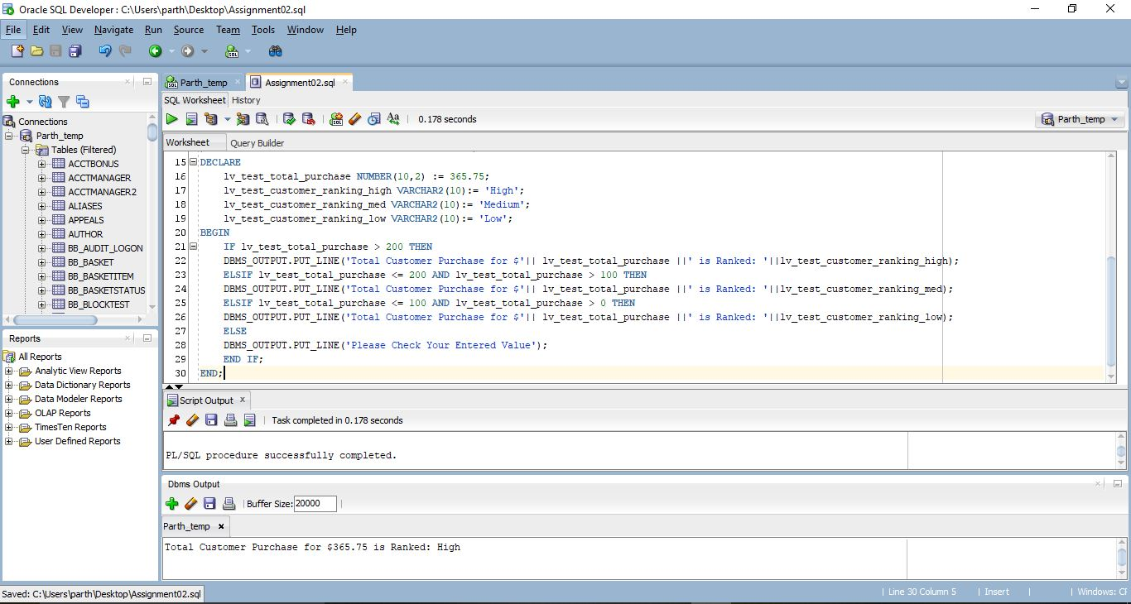

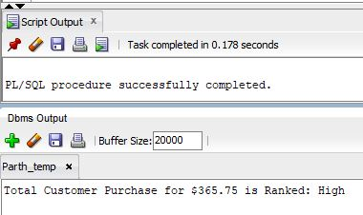

**ANSWER 04**

# ANSWER 04 CODE:

DECLARE

lv_test_total_purchase NUMBER(10,2) := 189.77;

lv_test_customer_ranking_high VARCHAR2(10):= 'High';

lv_test_customer_ranking_med VARCHAR2(10):= 'Medium';

lv_test_customer_ranking_low VARCHAR2(10):= 'Low';

BEGIN

CASE

WHEN lv_test_total_purchase > 200 THEN

DBMS_OUTPUT.PUT_LINE('Total Customer Purchase for $'|| lv_test_total_purchase ||' is Ranked: '||lv_test_customer_ranking_high);

WHEN lv_test_total_purchase <= 200 AND lv_test_total_purchase > 100 THEN

DBMS_OUTPUT.PUT_LINE('Total Customer Purchase for $'|| lv_test_total_purchase ||' is Ranked: '||lv_test_customer_ranking_med);

WHEN lv_test_total_purchase <= 100 AND lv_test_total_purchase > 0 THEN

DBMS_OUTPUT.PUT_LINE('Total Customer Purchase for $'|| lv_test_total_purchase ||' is Ranked: '||lv_test_customer_ranking_low);

ELSE

DBMS_OUTPUT.PUT_LINE('Please Check Your Entered Value');

END CASE;

END;

# ANSWER 04 SCREEN SHOTS:

## LOW RATING

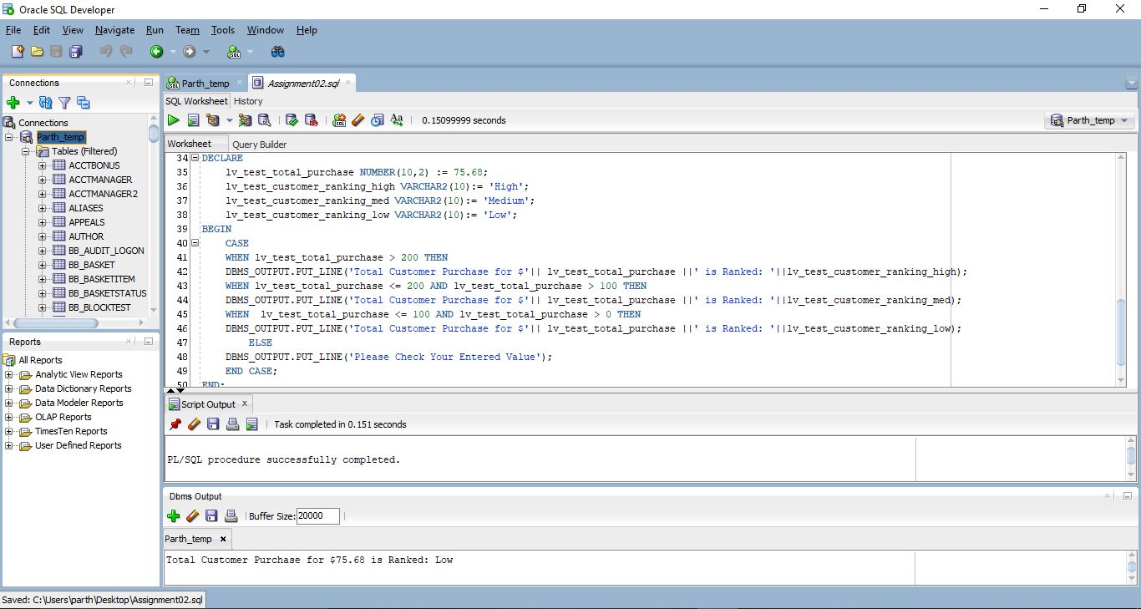

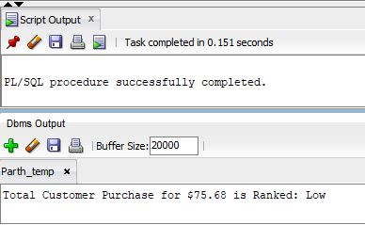

## MEDIUM RATING

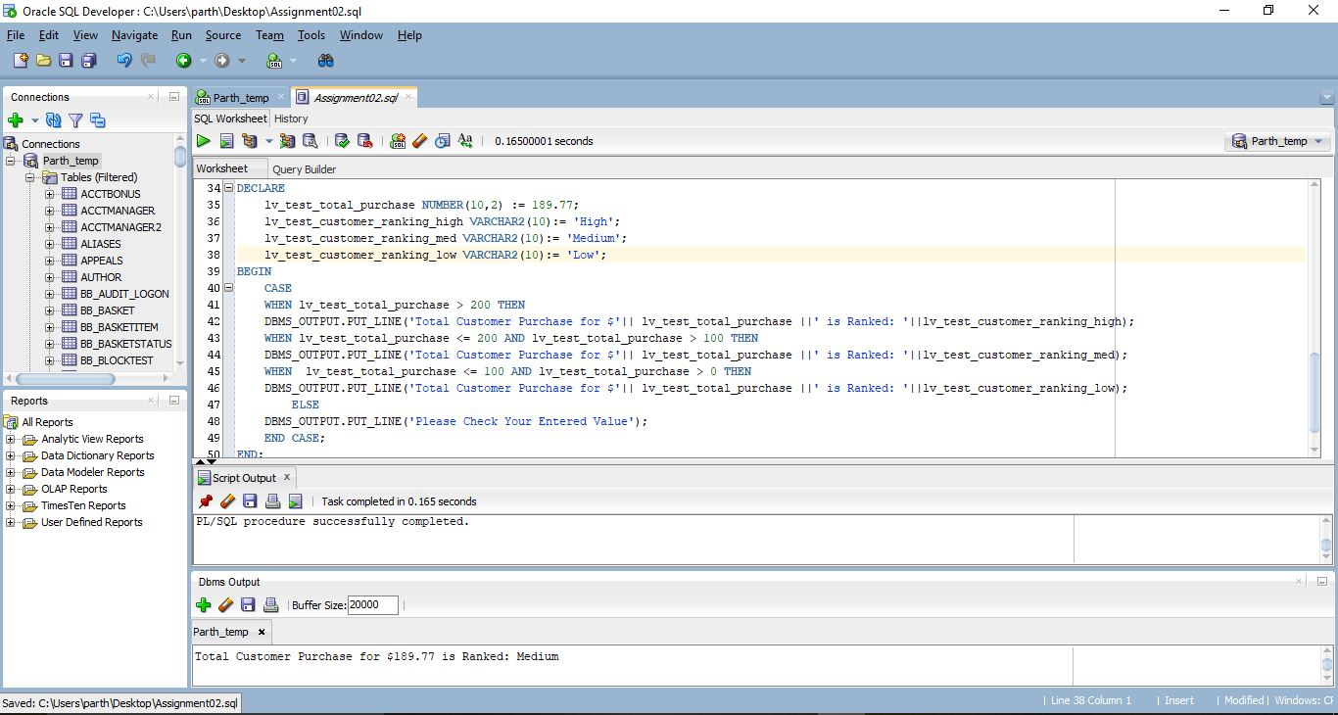

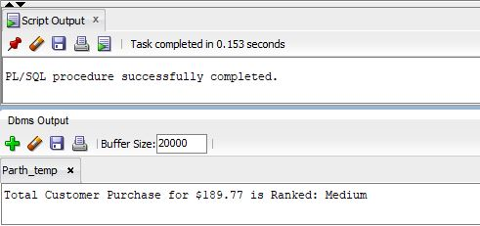

## HIGH RATING

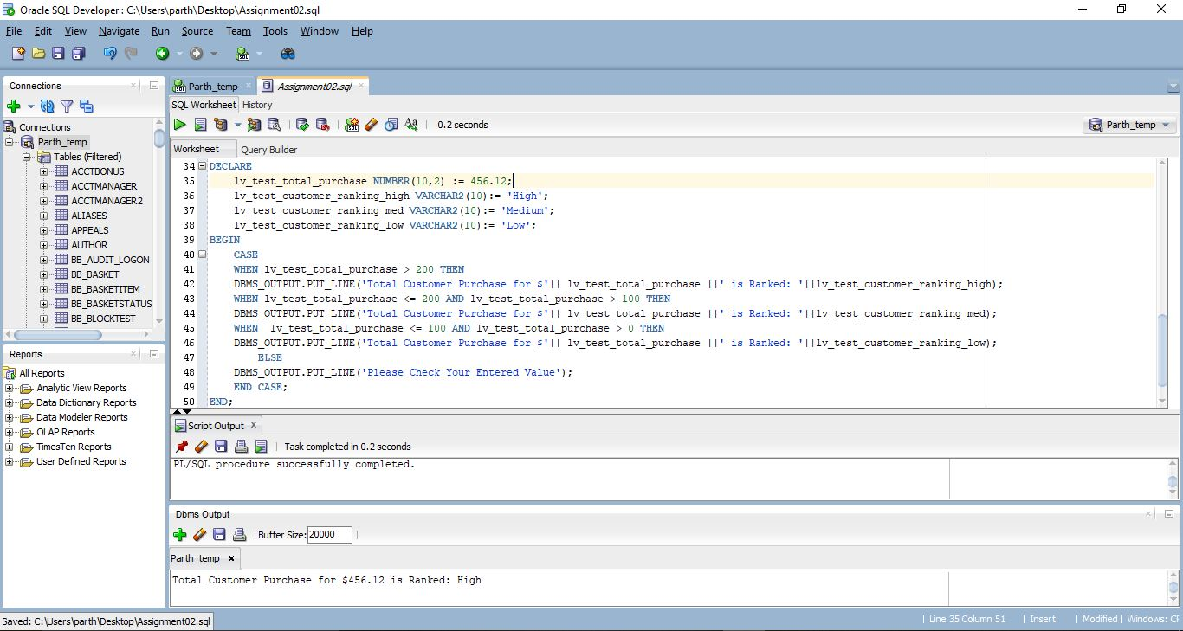

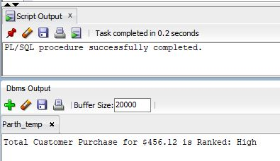

**ANSWER 05**

# ANSWER 05 CODE:

DECLARE

lv_test_account_balance DECIMAL(15,2) := 256.82;

lv_test_payment_amount DECIMAL(15,2) := 120.23;

lv_test_is_paid BOOLEAN := TRUE;

BEGIN

IF lv_test_payment_amount < lv_test_account_balance THEN

lv_test_is_paid := FALSE;

ELSIF lv_test_payment_amount = lv_test_account_balance OR lv_test_payment_amount > lv_test_account_balance THEN

lv_test_is_paid := TRUE;

ELSE

DBMS_OUTPUT.PUT_LINE('Something Went Wrong...');

END IF;

IF lv_test_is_paid = TRUE THEN

DBMS_OUTPUT.PUT_LINE('Customer has no due payment.');

ELSE

DBMS_OUTPUT.PUT_LINE('Customer has Amount $' || (lv_test_account_balance - lv_test_payment_amount) ||' Due and yet to be paid.');

END IF;

END;

# ANSWER 05 SCREEN SHOTS:

## PAID

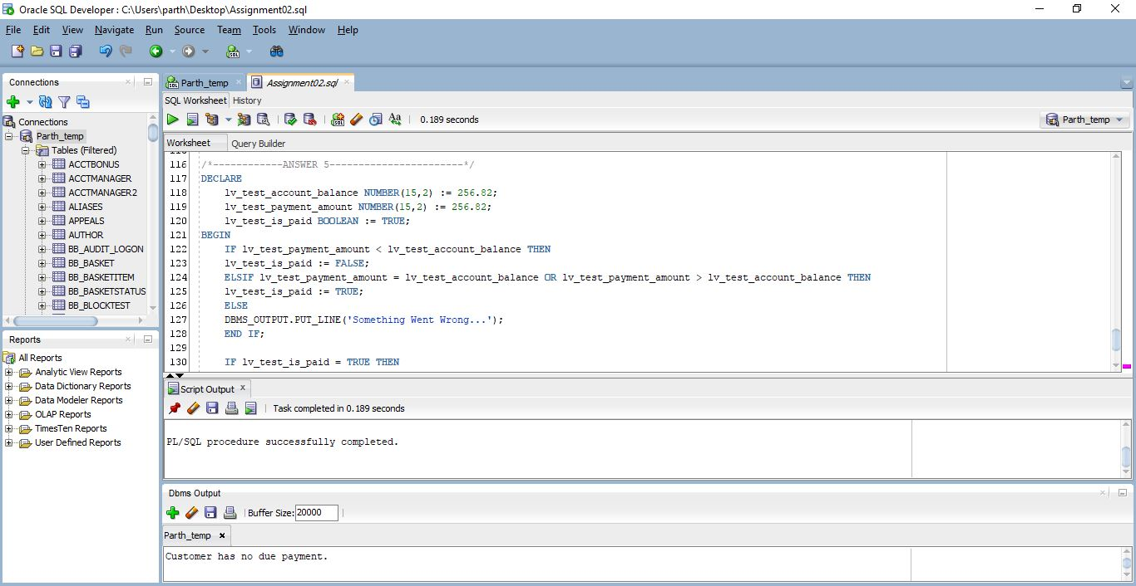

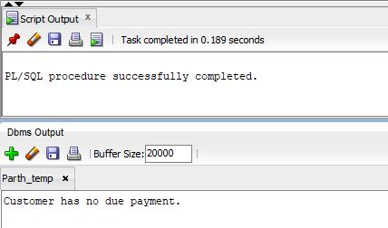

## NOT PAID

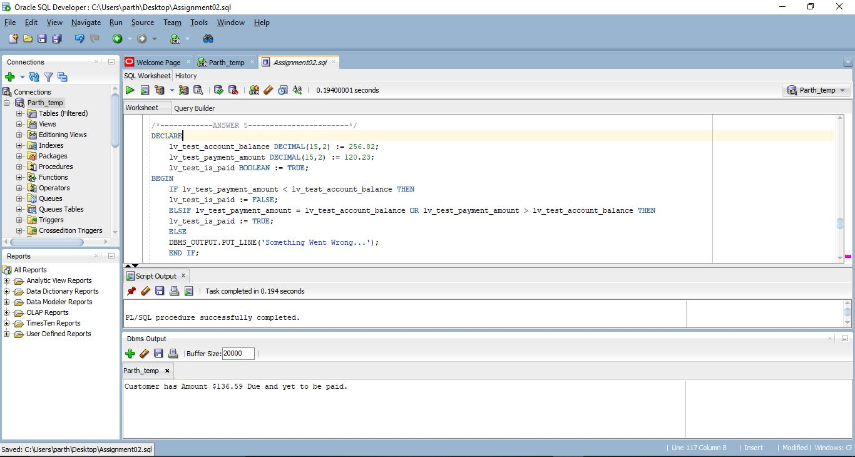

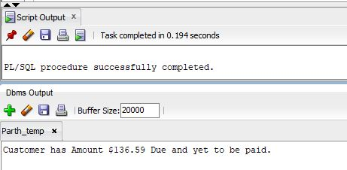

**ANSWER 06**

# ANSWER 06 CODE:

DECLARE

lv_test_calc_initial_amt DECIMAL(10,2) := 159.52;

lv_test_total_amount DECIMAL(10,2) := 159.52;

lv_test_no_of_item INTEGER := 0;

lv_test_item_price DECIMAL(10,2) := 10.32;

lv_test_amount_spent DECIMAL(10,2) := 0;

BEGIN

WHILE lv_test_total_amount > lv_test_item_price LOOP

lv_test_total_amount := lv_test_total_amount - lv_test_item_price;

lv_test_no_of_item := lv_test_no_of_item + 1;

END LOOP;

lv_test_amount_spent := lv_test_no_of_item * lv_test_item_price;

lv_test_total_amount := lv_test_calc_initial_amt - lv_test_amount_spent;

DBMS_OUTPUT.PUT_LINE('Amount Left: $'|| lv_test_total_amount);

DBMS_OUTPUT.PUT_LINE('Amount Spent: $'|| lv_test_amount_spent);

DBMS_OUTPUT.PUT_LINE('Number Of Item Purchased: '|| lv_test_no_of_item);

END;

# ANSWER 06 SCREEN SHOTS:

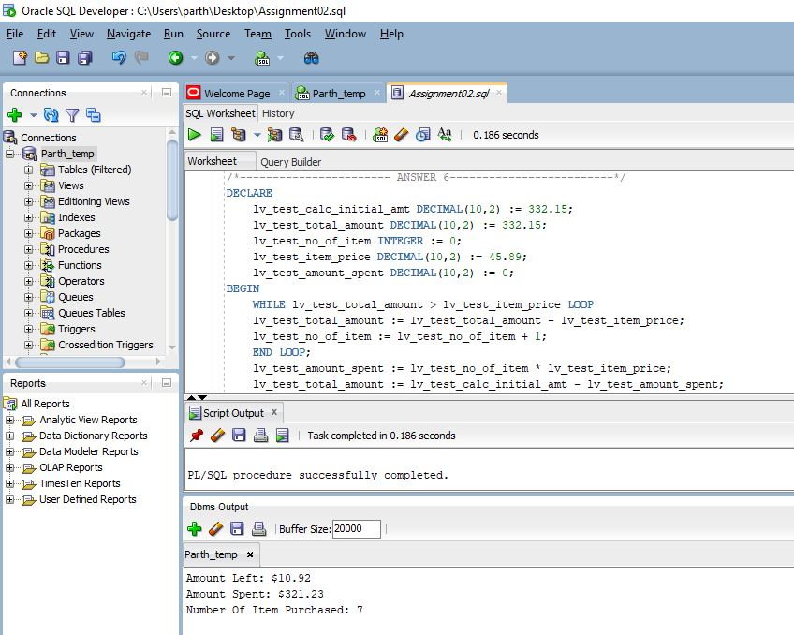

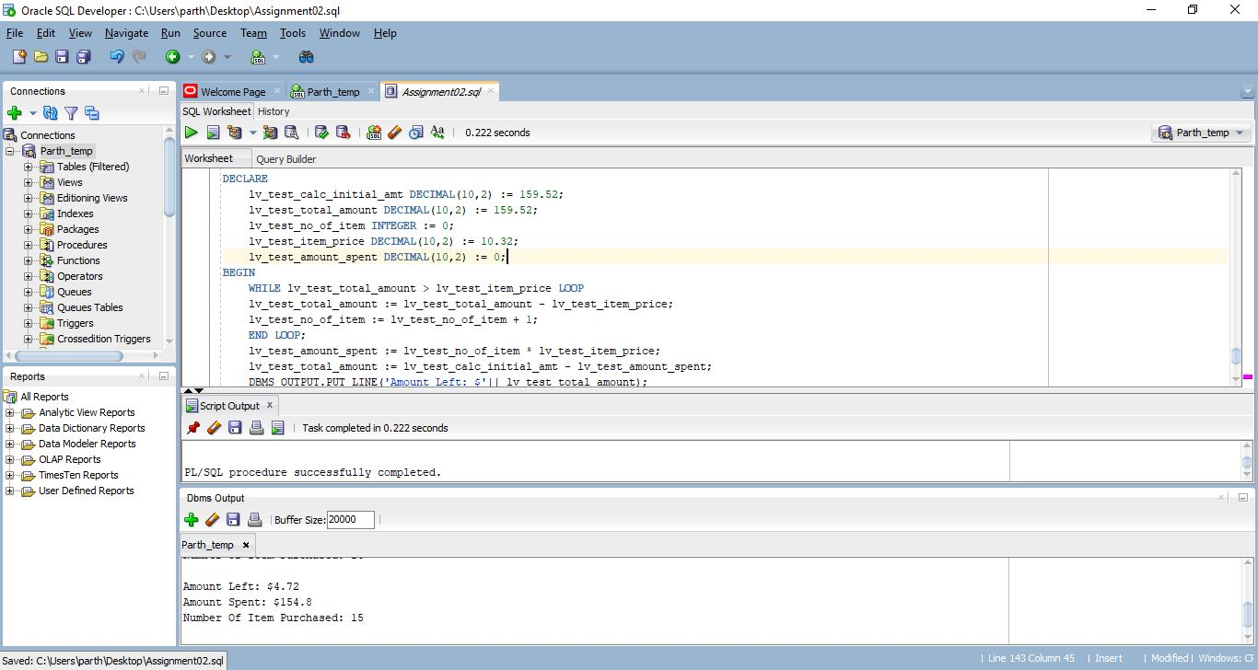

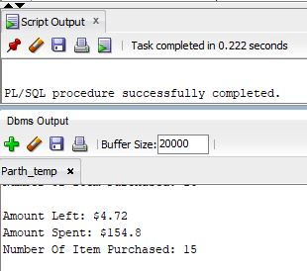

**ANSWER 07**

# ANSWER 07 Flowchart:



**ANSWER 08**

# ANSWER 08 CODE:

DECLARE

lv_test_is_member CHAR(1):= 'Y';

lv_test_quanity INTEGER := 10;

lv_test_price DECIMAL(8,2) :=0;

lv_net_total DECIMAL(8,2):= 0;

BEGIN

IF lv_test_quanity > 0 AND lv_test_quanity <= 3 THEN

IF lv_test_is_member = 'Y' THEN

lv_test_price := 3.00;

ELSE

lv_test_price := 5.00;

END IF;

lv_net_total := lv_test_price * lv_test_quanity;

ELSIF lv_test_quanity >= 4 AND lv_test_quanity <= 6 THEN

IF lv_test_is_member = 'Y' THEN

lv_test_price := 5.00;

ELSE

lv_test_price := 7.50;

END IF;

lv_net_total := lv_test_price * lv_test_quanity;

ELSIF lv_test_quanity >= 7 AND lv_test_quanity <= 10 THEN

IF lv_test_is_member = 'Y' THEN

lv_test_price := 7.00;

ELSE

lv_test_price := 10.00;

END IF;

lv_net_total := lv_test_price * lv_test_quanity;

ELSIF lv_test_quanity > 10 THEN

IF lv_test_is_member = 'Y' THEN

lv_test_price := 9.00;

ELSE

lv_test_price := 12.00;

END IF;

lv_net_total := lv_test_price * lv_test_quanity;

ELSE

DBMS_OUTPUT.PUT_LINE('Something is Wrong.....');

END IF;

DBMS_OUTPUT.PUT_LINE('-----------------------------');

IF lv_test_is_member = 'Y' THEN

DBMS_OUTPUT.PUT_LINE('You are a Member');

ELSE

DBMS_OUTPUT.PUT_LINE('You are not a Member');

END IF;

DBMS_OUTPUT.PUT_LINE('-----------------------------');

DBMS_OUTPUT.PUT_LINE('Price per Item: $' || lv_test_price);

DBMS_OUTPUT.PUT_LINE('Total Number of Items: ' || lv_test_quanity);

DBMS_OUTPUT.PUT_LINE('-----------------------------');

DBMS_OUTPUT.PUT_LINE('Total Amount to Pay: $' || lv_net_total);

END;

# ANSWER 08 SCREEN SHOTS:

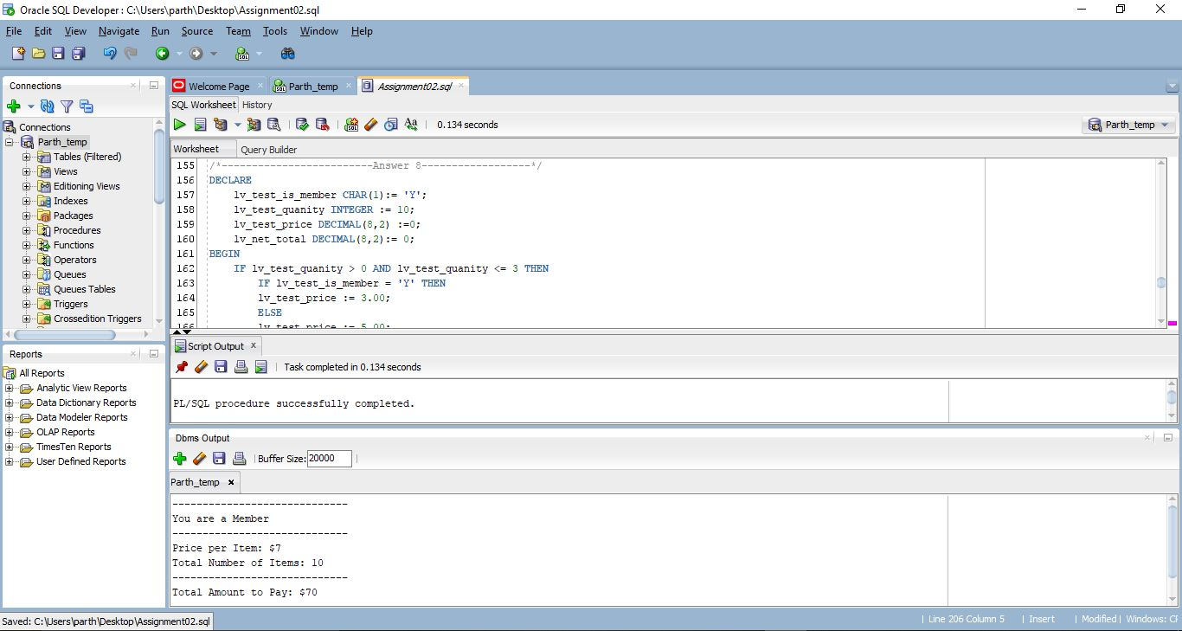

## IS MEMBER AND QUATITY IS LESS THAN OR EQUAL TO 3

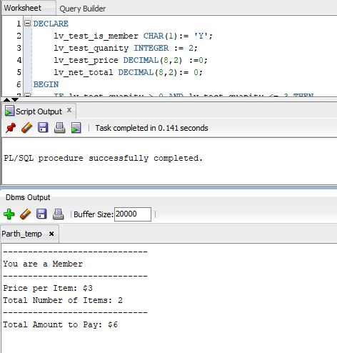

## NOT A MEMBER AND QUATITY IS LESS THAN OR EQUAL TO 3

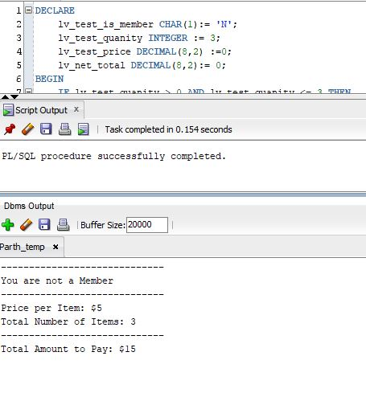

## IS MEMBER AND QUATITY IS LESS THAN OR EQUAL TO 6 BUT GREATER THAN OR EQUAL TO 4

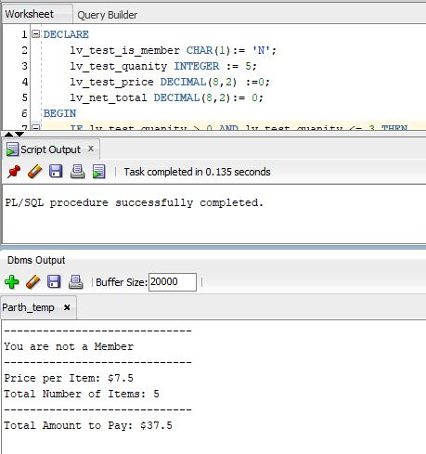

## NOT MEMBER AND QUATITY IS LESS THAN OR EQUAL TO 6 BUT GREATER THAN OR EQUAL TO 4



## IS MEMBER AND QUATITY IS LESS THAN OR EQUAL TO 10 BUT GREATER THAN OR EQUAL TO 7

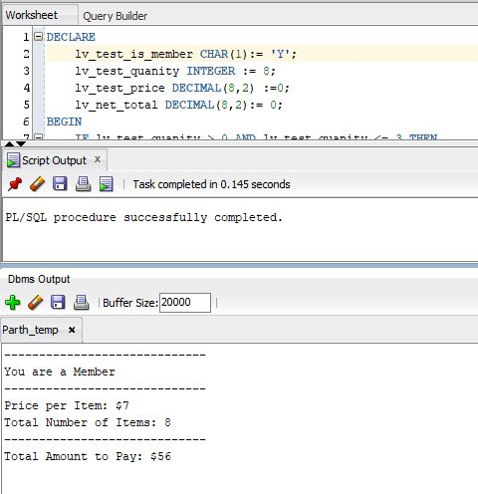

## NOT MEMBER AND QUATITY IS LESS THAN OR EQUAL TO 10 BUT GREATER THAN OR EQUAL TO 7

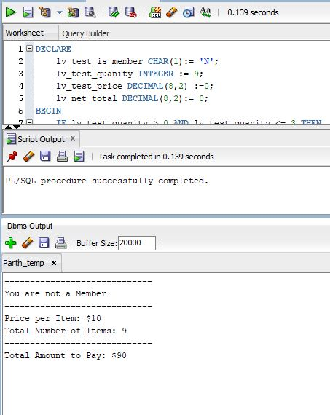

## IS MEMBER AND QUATITY GREATER THAN 10

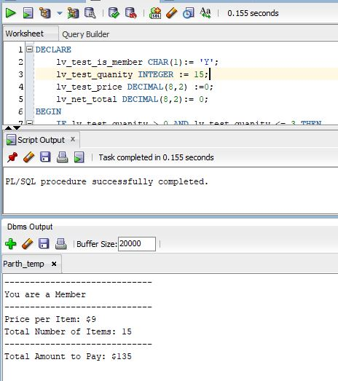

## NOT A MEMBER AND QUATITY GREATER THAN 10

